E TICKET BOOOKING

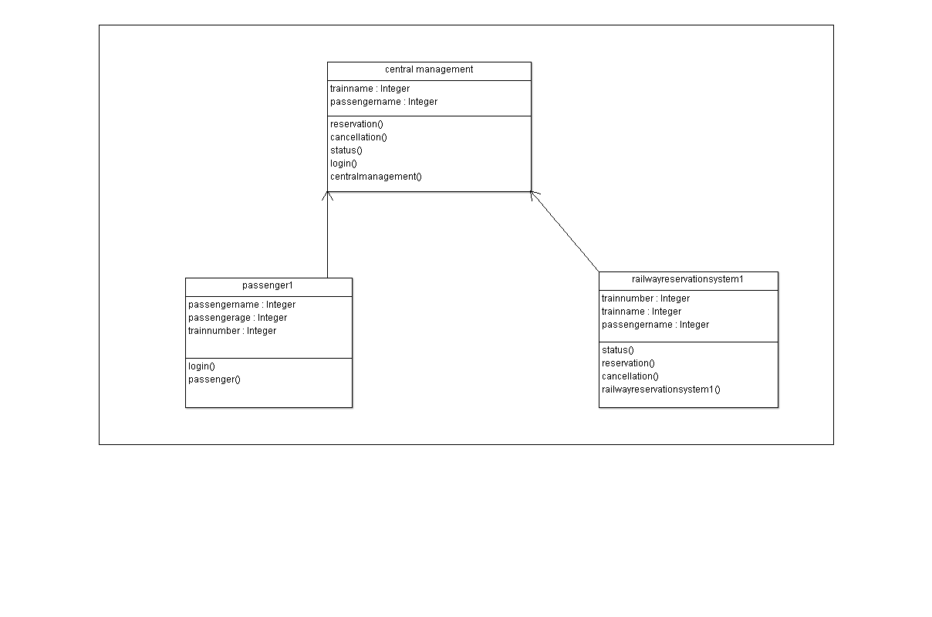

CODE: public class central management {

public Integer trainname;

public Integer passengername;

public void reservation() {

}

public void cancellation() {

}

public void status() {

}

public void login() {

}

public void centralmanagement() {

}

}

import java.util.Vector;

public class railwayreservationsystem1 {

public Integer trainnumber;

public Integer trainname;

public Integer passengername;

public Vector mycentral management;

public void status() {

}

public void reservation() {

}

public void cancellation() {

}

public void railwayreservationsystem1() {

}

}